Activity No. <n>
<Hands-on Activity 2.1: Data Types and Arithmetic Operations
>
Course Code: CPE007 | Program: Computer Engineering
Course Title: Data Structures and Algorithms | Date Performed:8/7/2025
Section:CPE11S1 | Date Submitted: 8/7/2025
Name(s): Hanz Rhayven M. Pabalan | Instructor: Jimlord Quejado
6. Output
1: Example #1
Error:
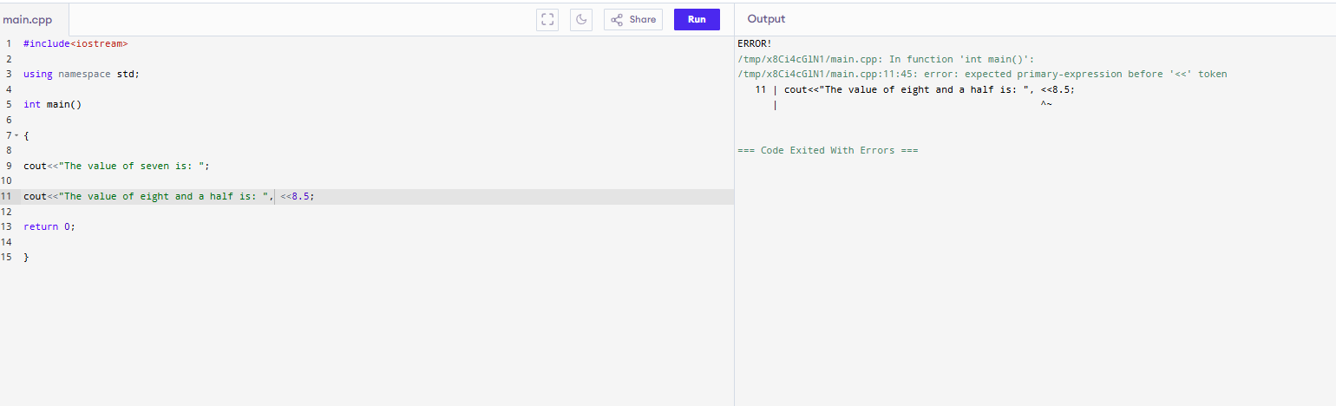
Result:
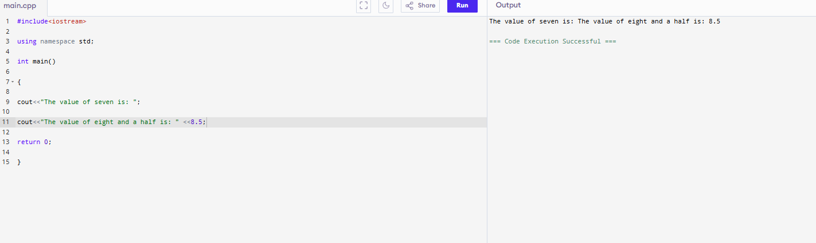
2: Example #2
Error:
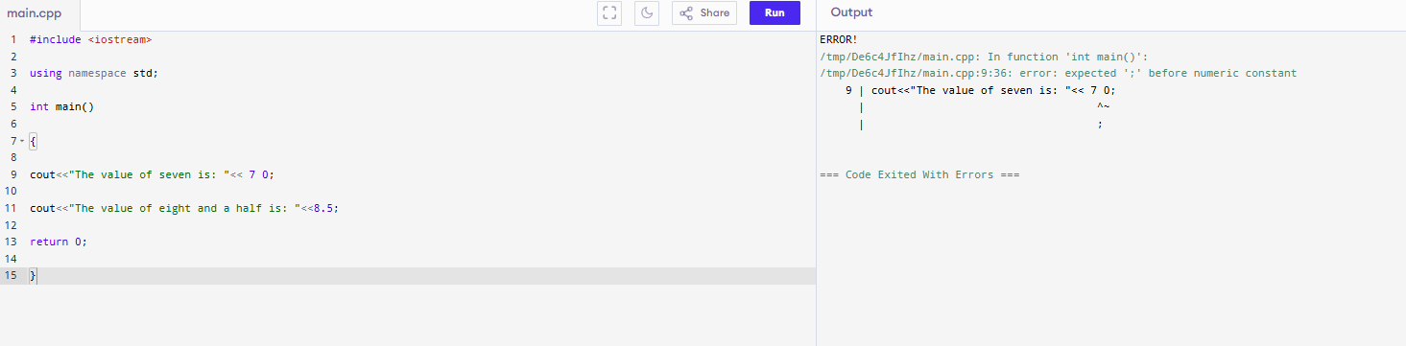
Result:
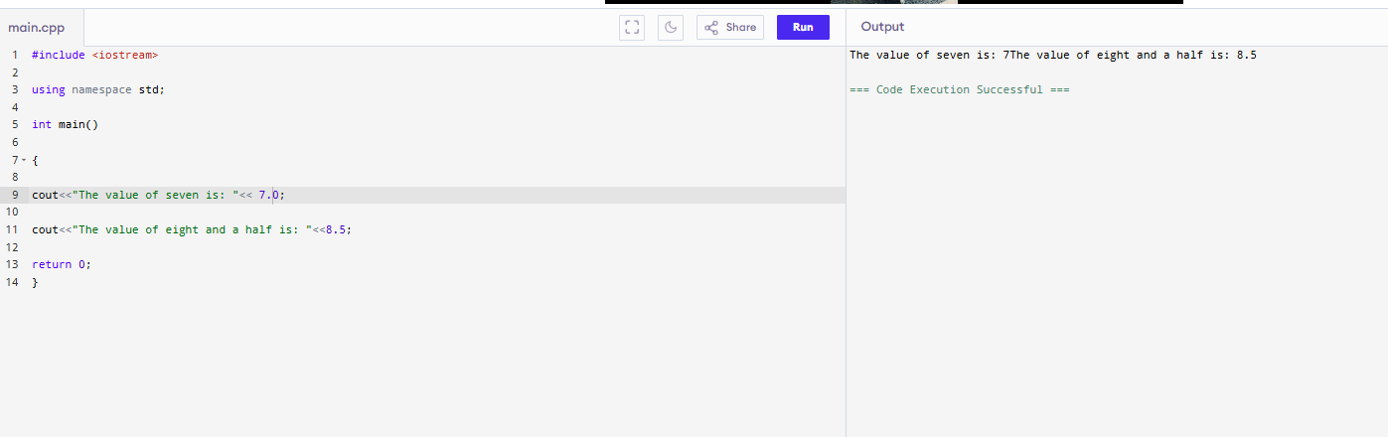

3: Example #3
Error:
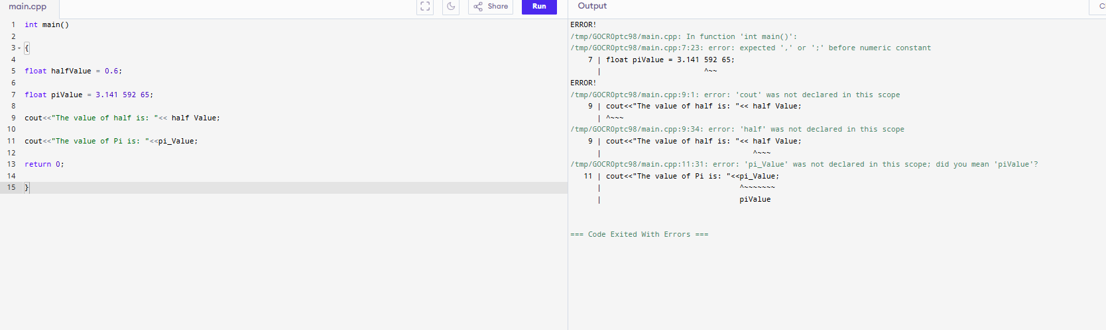
Result:
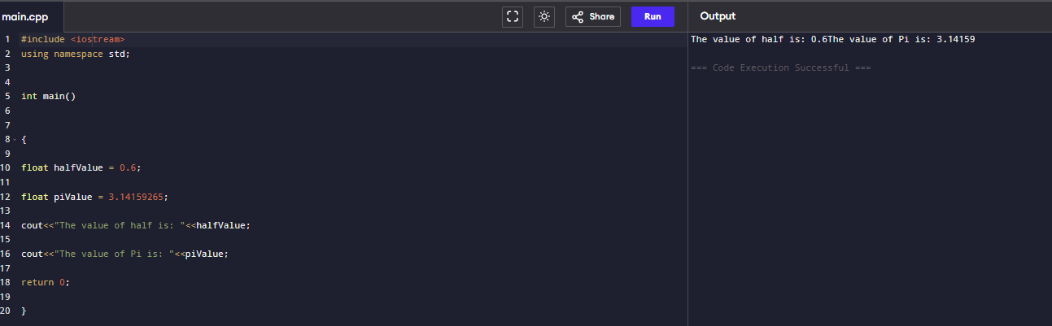
4: Example #4
Error:
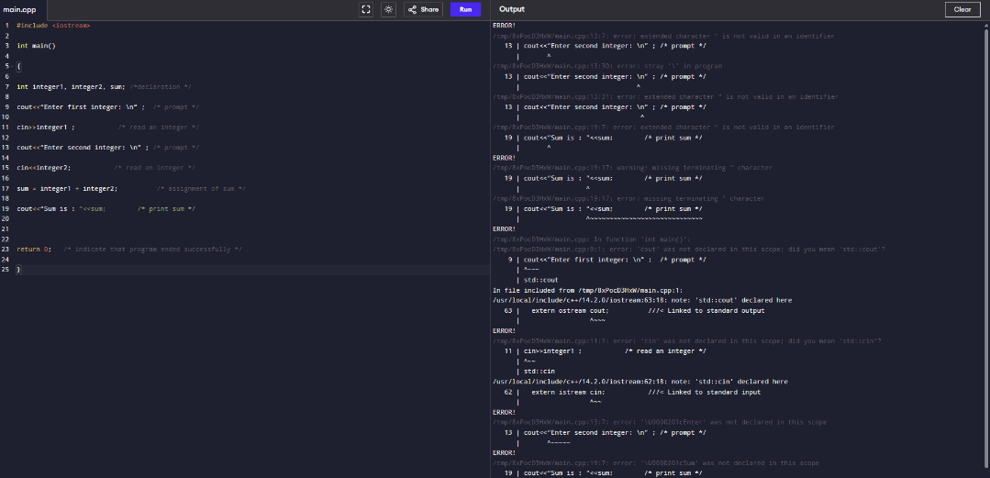
Result:
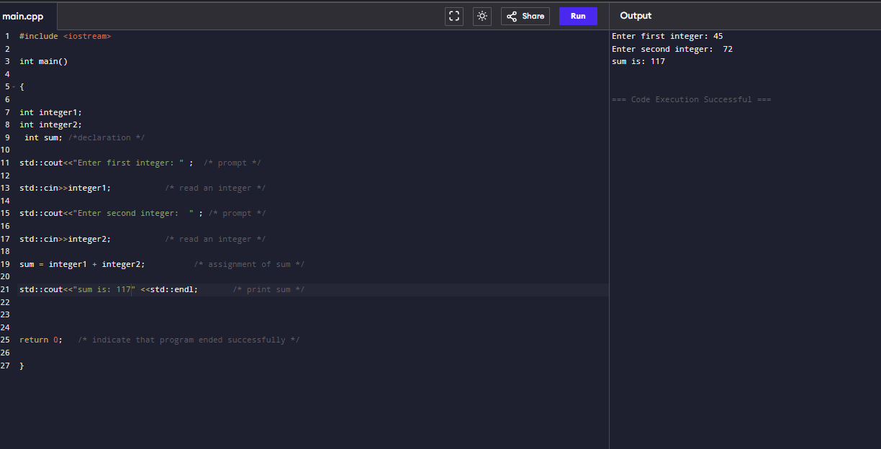
7. Supplementary Activity
- Take a look at the code below: it assigns two integer values, manipulates them and finally outputs the result and bigresult variables. The problem is that the manipulations have been described using natural language, so the code is completely useless now. Act as an intelligent (naturally!) compiler and translate the formula into a real "C" code notation. Test your code using the data provided.
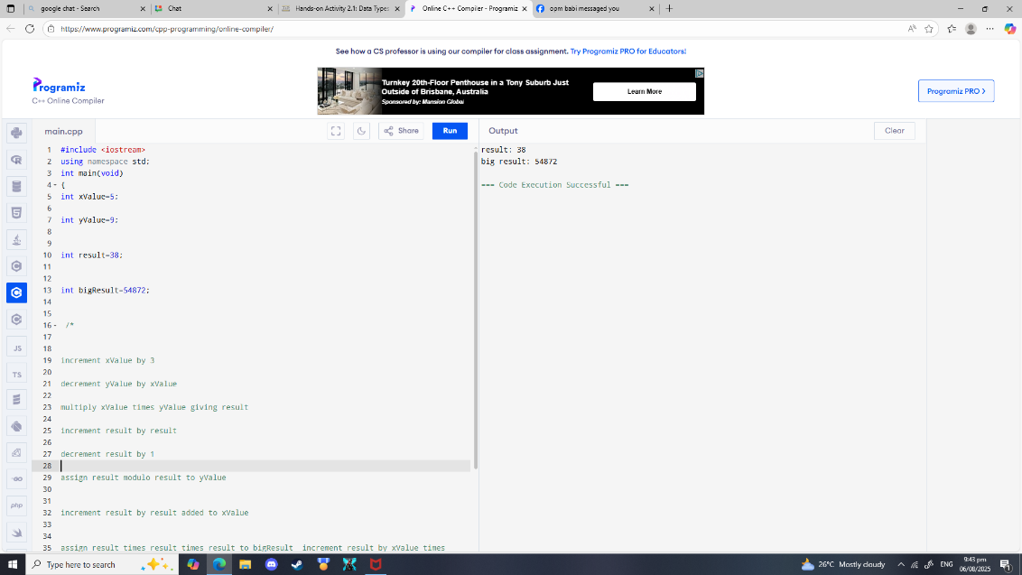
- Complete the program below. Compute the accrued amount of money with a starting value of 100 and an annual interest rate of 1.5%. Compute and print the results for first three years. Your version of the program must print the same result as the expected output for every year. Compute each annual value on the basis of the previous year's value.
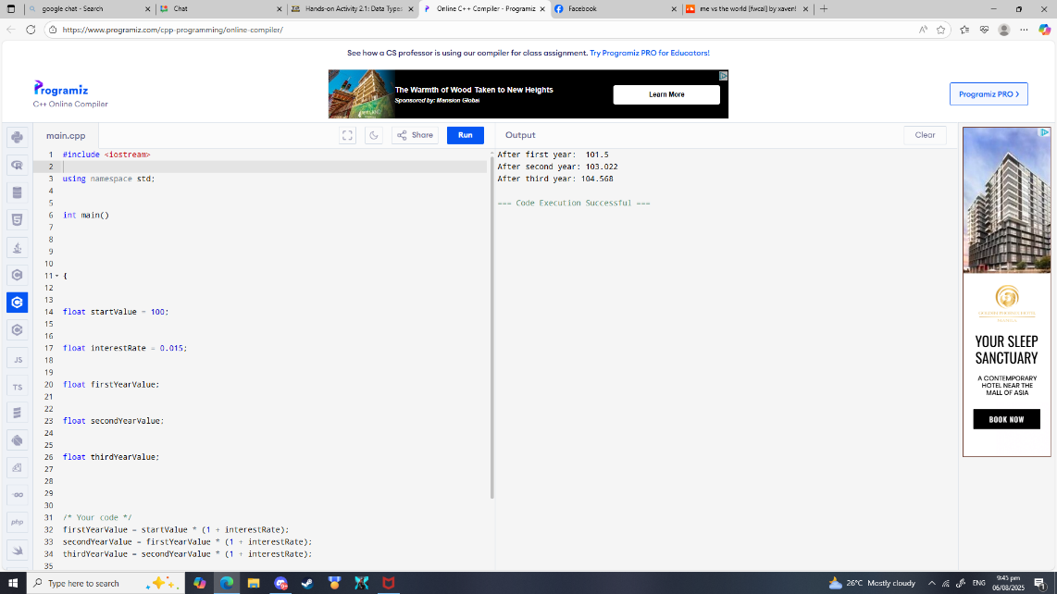

8. Conclusion
With this topic I leaned how to find program errors more easily and how to solve the because it was really a challenge for me because im new to this but I learn it easily because of this topic.
9. Assessment Rubric

